SAFETY EQUIPMENT FORM
OBRAZAC SIGURNOSNE OPREME
START NO.  STARTNI BR. |  | 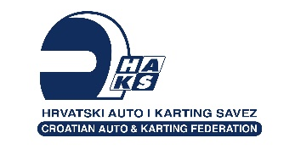
NAME AND SURNAME
IME I PREZIME

 | MAKE & MODEL  MARKA & TIP | STANDARD | HOMOLOGATION NUMBER  (IF AVAILABLE) HOMOLOGACIJSKI BROJ (AKO POSTOJI)
SEAT
SJEDALO
SEAT BELTS POJASEVI
HELMET KACIGA
OVERALL KOMBINEZON
UNDERWEAR DONJE RUBLJE
SHOES
OBUĆA
GLOVES RUKAVICE

SIGNATURE  POTPIS | SCRUTINEERS SIGNATURE  POTPIS VODITELJA TKO

