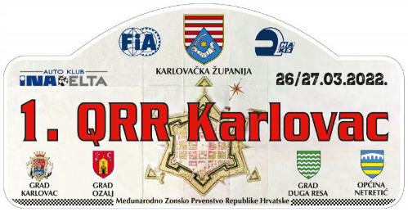

START NUMBER

P R I J A V N I L I S T

ENTRY REGISTRATION FOR:  (mark with X) | GEN |  | MZPH |  | PH |  | OPZ

MZPH - International Zone Croatian Championship, PH - Croatian Championship, OPZ - Open Zagreb Championship

 | COMPETITOR | FIRST DRIVER | CO-DRIVER
Team name
Family name
First name
Date of birth
Nationality (as licence)
Postal address
Passport number
Address for correspondence
Telephone (business)
Telephone (private)
Mobile
Fax
E mail
Competitions licence No.
Issuing ASN
Driving licence No.

DETAILS OF CAR
Make |  | Country of registration
Model |  | Registration No.
Year of manufacture |  | C.C.
Class (GEN, CEZ, MZPH, PH, OPZ) |  | Engine No
Homologation No. |  | Tech. Passport No.

Organiser’s proposed advertising accepted (choose): | YES | NO
Junior (choose): | YES | NO
Ladies trophy (choose): | YES | NO

ENTRY FEE
(for this entry form to be valid it must be accompanied by the appropriate entry fees, a receipt for the full amount paid to the entrants ASN, a bankers draft or details of a bank transfer etc.)

MZPH | 4, S1, H, Juniori | S2 | S3 | Other class
Until 18. 3. 2022. | 1.450,00 kn | 1.600,00 kn | 1.850,00 kn | 2.100,00 kn
Administrative checks | 2.900,00 kn | 3.200,00 kn | 3.700,00 kn | 4.200,00 kn
PH | 4, S1, H, Juniori | S2 | S3 | Other class
Until 18. 3. 2022. | 850,00 kn | 1.000,00 kn | 1.250,00 kn | 1.500,00 kn
Administrative checks | 1.700,00 kn | 2.000,00 kn | 2.500,00 kn | 3.000,00 kn

SEEDING INFORMATION

Driver: _______________________________________

Priority: YES / NO If yes, choose: FIA A / FIA B / National National Championship winner: YES / NO

Year |  | Event | Car | Group | O/A Position | Class Position | No. of Finishers
Championship

DECLARATION OF INDEMNITY
The entrant, driver and co-driver jointly and severally acknowledge and agree the following:
- To abide by and be bound by the codes and regulations of the 1.th QRR 2022, held under the International Sporting Code, the Sporting and Technical Regulations of the FIA, the Regulations of the relevant National Sporting Authority (ASN) and the Supplementary Regulations issued for the 1th QRR 2022.
- That motor sport is dangerous and accidents causing death, bodily damage, disability and property damage can and do happen and in consideration of the acceptance of this entry, we agree that neither the FIA, the relevant ASN, the organisers and/or promoters and their respective officers, servants, representatives and agents and any other parties shall be under any liability for our death, or any bodily injury, loss or damage which may be sustained or incurred by us as a result of participation in the 1th QRR 2022, and to the fullest permitted by law agree to indemnity and hold harmless each of those parties.

ACKNOWLEDGEMENT AND AGREEMENT
By me signature I declare that all the information contained on the entry form is correct and that I acknowledge and agree in full to the terms and conditions of the above indemnity and that I accept all the terms and conditions relating to my participation in this event.

Signing this entry form for entry on "1.QRR 2022." Applicant (crew and competitor) gives an explicit privilege to Organizer, as voluntary, particular, informed and unambiguous consent for using and processing personal data which refer to Applicant, and which processing is necessary for organization of this manifestation.

ASN Stamp* | Signature of Competitor | Signature od First Driver | Signature of Co-driver

* Or letter from the entrant’s ASN authorising and approving the entry

Date ___________________________________ E-mail for entries: qrr@ak-inadelta.hr

